Personal Health Record (PHR) Application
Page URL: https://abdm-docs.dev.eka.care/docs/hiecm/v3/concepts/participants/phr
Current Content  PHR app | You are the citizen's own app. You hold their identity, show them their records, and are the place where every consent decision is taken.
New Content  Personal Health Record (PHR) Application | The Personal Health Record (PHR) application functions as the primary digital interface for the Data Principal (citizen) within the Ayushman Bharat Digital Mission (ABDM) ecosystem. It facilitates digital identity management, provides access to longitudinal health records, and serves as the centralized node for consent artifact management.

Current Content  Who you are in ABDM | A PHR application acts for the citizen, and a citizen and a facility sit on opposite sides of the HIE-CM. That position is fixed for the life of your product.  You hold no registry identifier of your own. Your users hold the ABHA numbers and addresses, and everything routes on the address. Your own credentials are the client id and client secret issued at sandbox signup, which you exchange for a session token.  Within that position the citizen takes both directions through your app. Your user is the HIU whenever you fetch their records, and the HIP the moment they link or push one from your app.  To be listed for deep links, submit three things at sandbox exit: your application name, your Play Store URL and your App Store URL.
New Content  Role and Positioning within the ABDM Architecture | The PHR application operates on behalf of the citizen and securely connects with healthcare facilities through the HIE-CM. Health Data is routed using the citizen’s ABHA address, with PHR application acts as an HIU for fetching clinical records and a HIP for sharing user-uploaded health documents and facility linked health documents, and must be listed in the ABDM Application Directory after Sandbox exit with its official name and marketplace URLs

Current Content  What you can do | 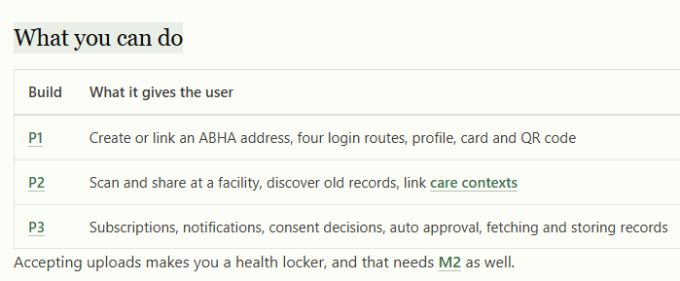
New Content  Authorized Capabilities and Milestones
  Integration Phase | Functional Capabilities
  Phase 1 (P1) | Facilitation of ABHA number and address creation, multiple authentication (four mandated login routes).
  Phase 2 (P2) | Execution of facility-level Scan & Share, profile management, ABHA card and QR code generation, legacy record discovery, and standardized Care Context linkage.
  Phase 3 (P3) | Management of user locker subscriptions and system notifications, execution of consent decisions (approval/rejection), configuration of auto-approval policies, and the secure retrieval and storage of health records.
  Health Locker (M2) | Processing direct document uploads by the Data Principal necessitates certification as a Health Locker (Health Repository Provider), which requires the successful completion of Milestone 2 (M2) integration.

Current Content  Why it is worth it | You are the only participant the citizen actually sees. Every consent request raised anywhere on the network arrives in your app, and the decision is made there.  The HIE-CM tells you when a care context is created or updated for a subscribed address, so records reach your user without them chasing a facility. You then store those records for the long term, which no other participant does on the citizen's behalf.
New Content  Significance and Ecosystem Value | The PHR application platform empowers citizens by providing a central interface for consent management and control over their health information. Through HIE-CM, users receive notifications on the creation or modification of Care Contexts linked to their ABHA address, enabling seamless aggregation of longitudinal health records based on approved consent policies. In addition, PHR applications and Health Lockers provide secure, long-term, user-managed storage of health records, complementing the statutory record-retention responsibilities of healthcare establishments.

